5. Analyze the Histogram of an Image Based on Color Levels Using OpenCV
Aim: To write a Python function to analyze the histogram of an input image based on color levels using OpenCV.
Procedure
- Import the OpenCV and Matplotlib libraries.
- Read the input image.
- Calculate the histogram for the Red, Green, and Blue color channels.
- Plot the histograms using Matplotlib.
- Display the original image and its color histogram.
Code
import cv2
import matplotlib.pyplot as plt

def analyze_histogram(image_path):
img = cv2.imread(image_path)

if img is None:
print("Image not found")
return

colors = ('b', 'g', 'r')
labels = ('Blue', 'Green', 'Red')

plt.figure(figsize=(8, 5))

for i, color in enumerate(colors):
hist = cv2.calcHist([img], [i], None, [256], [0, 256])
plt.plot(hist, color=color, label=labels[i])

plt.title("Color Histogram")
plt.xlabel("Color Levels")
plt.ylabel("Pixel Count")
plt.legend()
plt.show()

cv2.imshow("Original Image", img)
cv2.waitKey(0)
cv2.destroyAllWindows()

analyze_histogram("sample.jpg")
Input
An image named sample.jpg saved in the same folder as the Python program.
Output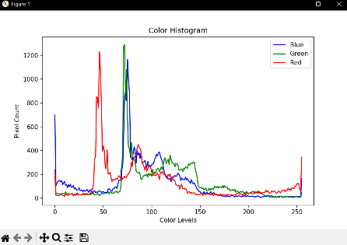
Result
The histogram of the input image was successfully analyzed using OpenCV, showing the distribution of pixel intensity levels for the Red, Green, and Blue color channels.

